**TABLES OF PROJECT:**

* Go to windows-¬>Oracle Database 10g Express…->Go to Database Home page->Database Login->SQL->SQL Commands
* Run

**Register Table:**

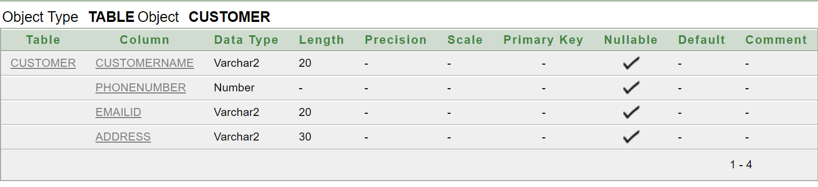

**Order Table:**

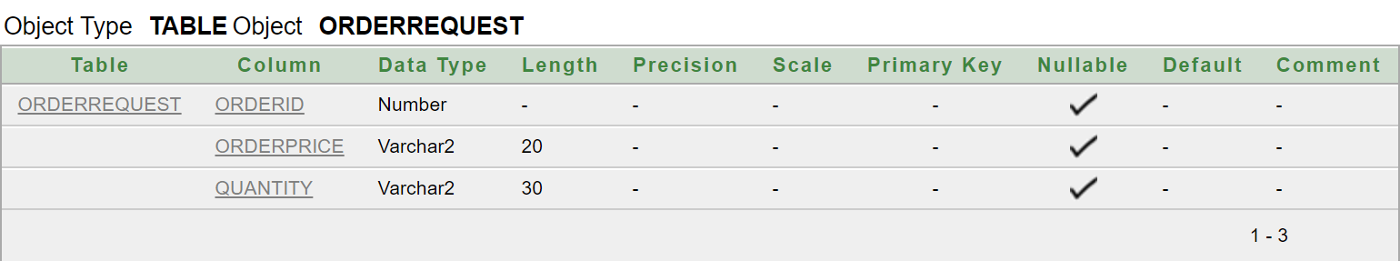

**Contact Table:**

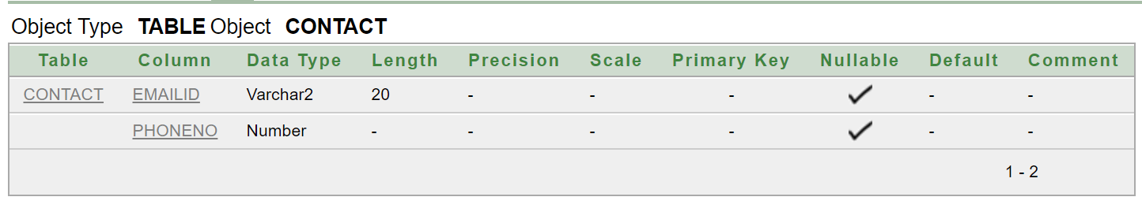

**Feedback Table:**

